**Assignment 4: Becoming an Independent Data Scientist**

**Region and Domain**

Reno, Nevada and weather phenomena

**Question**

How does the climate of Reno, NV compare with the climate of Miami, FL?

**Data**

https://www.usclimatedata.com/climate/reno/nevada/united-states/usnv0076

https://www.usclimatedata.com/climate/miami/florida/united-states/usfl0316

**Figure**

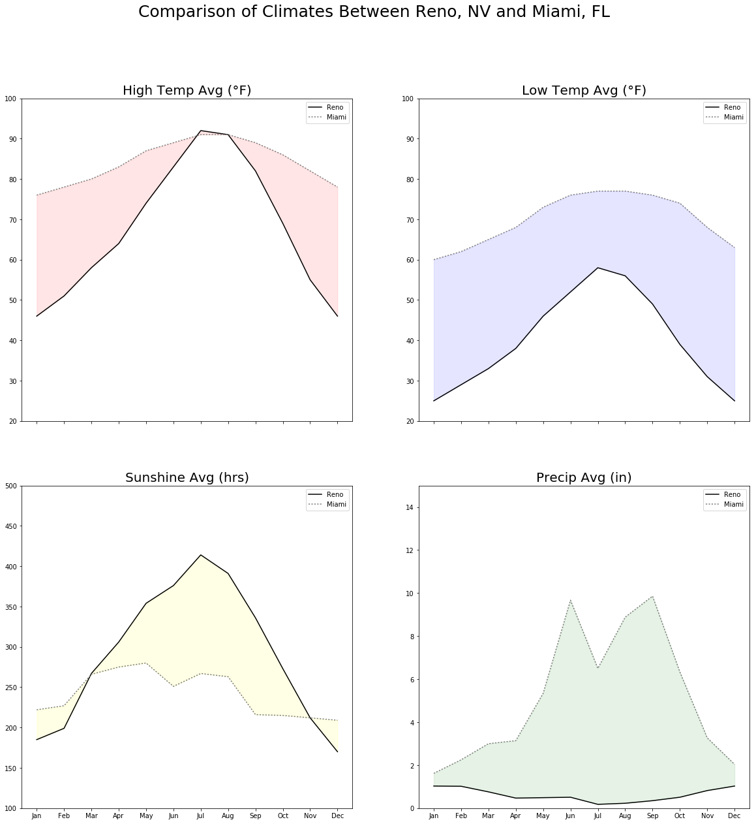

**Discussion**

This visualization is meant to show a comparison of the climates between Reno, NV and Miami, FL. The visual accomplishes this by exploring four key areas that people general want to know about when trying to understand what the weather is like in a particular locale (1) high temperature (2) low temperature (3) sunshine (4) rainfall.

(1) High Temperature

The visual allows the audience to see how Miami tends to have higher high temperatures year-round than Reno. However, one will not that the summer in Reno actually can get hotter than the summer in Miami.

(2) Low Temperature

The visual shows that the average low temperatures are consistently significantly lower in Reno than Miami.

(3) Sunshine

The visual outlines the greater amounts of sunshine in Reno for most of the year and especially in the summer. However, Miami exhibits a bit more sun in the winter months.

(4) Precipitation

The visual shows a large discrepancy in rainfall for Miami throughout the year and consistent low rainfall for Reno. The rainfall peaks in Miami can also be seen to correspond roughly to the months where Reno’s sunshine is much greater.